Hank Hanegraaff affirms that virtually the entire book of Revelation, aside from the Second Coming of Christ and the final resurrection of the just and unjust (which makes him a “partial Preterist”, (Preterism is a Christian eschatological (Eschatology, from two Greek words meaning last (ἔσχατος, last) and study (λογία, lit. discourse), is the study of the end of things, whether the end of an individual life, the end of the age, or the end of the world.) view that interprets Prophecies of the Holy Bible, especially Daniel and Revelation, as events which have already happened in the first century A.D.. Preterism holds that Ancient Israel finds its continuation or fulfillment in the Christian Church at the destruction of Jerusalem in AD 70. )), and thus Propecy from Daniel and Revelation was fulfilled by 70 AD. In other words, the promises to the Jews have ceased, and the "New Israel" those Jews internally, have now received the promises to Abraham. The Jews have no future part in God's plan, as they turned from God and crucified the Lord Jesus Christ of Nazareth. Hank Hanegraaff also believes that the Antichrist was Nero Caesar (which from Latin to Hebrew adds up to the number 666) (Hank Hanegraaff's book, The Apocalypse Code, pp. 8, 109, 114-115, 144, 147-149, 242, 255, 256) and the Great Whore of Revelation 17 was ancient Israel (p. 234-235). (Good Roman Catholic doctrine -- Hank Hanegraaff, as they, the Roman Catholic "church" wants you to believe it was Nero who was "the AntiChrist," although he was certainly an AntiChrist. Why, because it is speaking of the Great Whore, a religious system, from ROME, not from Jerusalem. Why ROME? Simply because Jerusalem, during the time of the Apostle John, when Commanded by the Lord Jesus Christ of Nazareth to write DID NOT REIGN (rule) over the cities of the earth. Who did, that is, what CITY (State, meaning a City that was also a nation,) which ruled other nations -- ROME ruled all the way to England, and down into the Middle East into Jerusalem.
Note: Not will reign, but who REIGNETH (during the time the Book of Revelation was written, during the time of the Apostles) . . .
Revelation 17:9, 18
9And here is the mind which hath wisdom. The seven heads are seven mountains, on which the woman sitteth.
Note: The Seven Hills of Rome (Italian: Sette colli di Roma) east of the river Tiber form the geographical heart of Rome, within the walls of the ancient city. http://en.wikipedia.org/wiki/Seven_hills_of_Rome
The seven hills are:
Aventine Hill (Latin, Aventinus; Italian, Aventino)
Caelian Hill (Caelius, Celio)
Capitoline Hill (Capitolinus, Capitolino/Campidoglio)
Esquiline Hill (Esquilinus, Esquilino)
Palatine Hill (Palatinus, Palatino)
Quirinal Hill (Quirinalis, Quirinale)
Viminal Hill (Viminalis, Viminale)
18And the woman which thou sawest is that great city, which reigneth over the kings of the earth.
According to Hank Hanegraaff, “‘Intoxicated with the wine of her adulteries,’ they (the Jews) fail to recognize the Messiah in their midst. Tragically, Israel, called to be a light to those in darkness, aligns herself with Caesar in piercing Christ and persecuting Christians. The golden cup in her hand is filled with ‘the blood of prophets and of the saints and of all who have been killed on the earth’ (Revelation 18:24). Shrouded in mystery, she was glorious—like ‘the most beautiful of jewels’ (Ezekiel 16:7). Unveiled as apostate Israel, SHE IS GROSTESQUE.” (p. 123) (Note: Man, that John the Beloved did NOT like the Jews!)
Note: I've attached a view pictures showing the Roman Catholic "church" as a woman holding the Golden Cup.

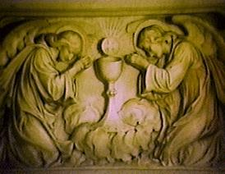
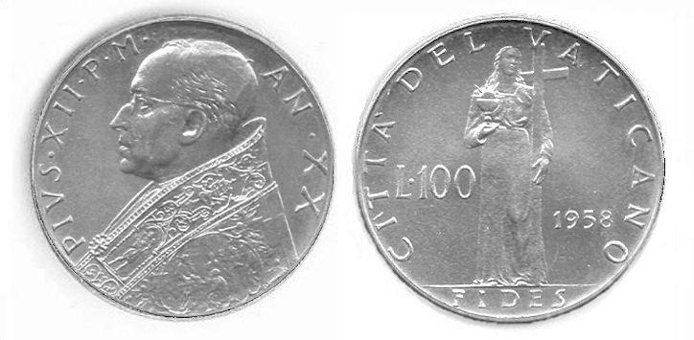





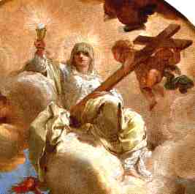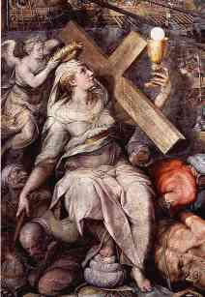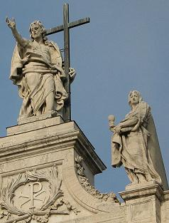


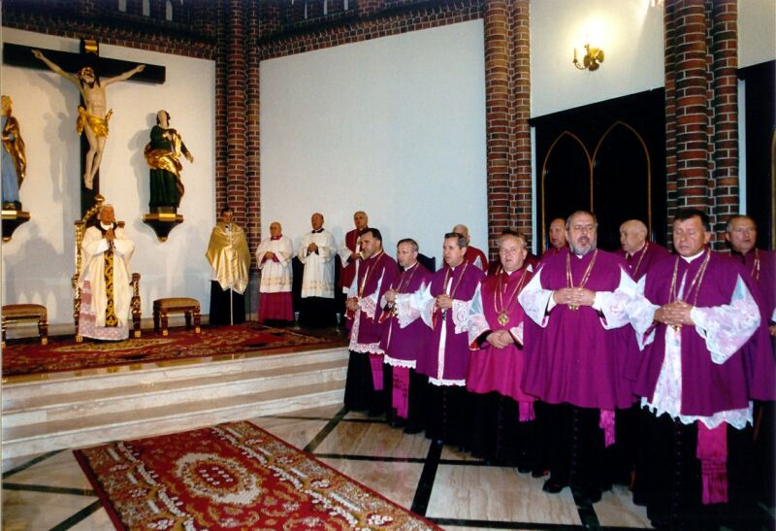

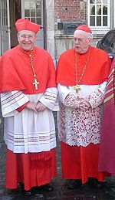

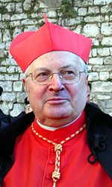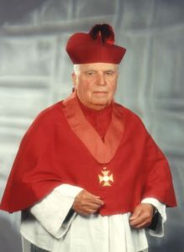

Revelation 17:4-5
4And the woman was arrayed in purple and scarlet colour, and decked with gold and precious stones and pearls, having a golden cup in her hand full of abominations and filthiness of her fornication:
5And upon her forehead was a name written, MYSTERY, BABYLON THE GREAT, THE MOTHER OF HARLOTS AND ABOMINATIONS OF THE EARTH.

So, according to Hank Hanegraaff, the Apostle John did not like the Jews! This has NOTHING to do with what is Commanded of the Apostle John by the Lord Jesus Christ of Nazareth, to write the things that ARE ("and the things which are,"), (": for the time is at hand"), (and write concerning the things which shall be hereafter;):
Revelation 1:1-3, 19
1The Revelation of Jesus Christ, which God gave unto him, to shew unto his servants things which must shortly come to pass; and he sent and signified it by his angel unto his servant John:
2Who bare record of the word of God, and of the testimony of Jesus Christ, and of all things that he saw.
3Blessed is he that readeth, and they that hear the words of this prophecy, and keep those things which are written therein: for the time is at hand.
19Write the things which thou hast seen, and the things which are, and the things which shall be hereafter;
"God is neither a cosmic rapist who forces his love on people, nor is he a cosmic puppeteer who forces people to love him. Instead God grants us the freedom of choice."
Hank Hanegraaff - blasphemous comment occurred on 4th February 2000
"Unfortunately there are people that take Revelation 17 and now cause Roman Catholicism to be the whore of Babylon, that simply is unfair, it is incorrect."
Hank Hanegraaff - NOT A DEFENDER OF THE FAITH - 28th April 1995
Hank Hanegraaff has had a problem with finances within his organization. http://www.ministrywatch.com/profile/christian-research-institute.aspx
In a “Christianity Today article published in July, 2003, correspondent Marshall Allen reported the particular concerns of the individual who instigated the investigation included the following: (1) $66,000 of CRI money went to the purchase of a blue Lexus for Hank Hanegraaff’s use; (2) receipts showing that thousands of dollars of CRI money went towards Hank Hanegraaff’s and his wife Kathy’s personal expenses; (3) Hank Hanegraaff’s rapidly escalating salary ($250,000+ in 2001 at an increase of 26.5% over the previous year). The ECFA report does not address the issue of Hank Hanegraaff’s salary, but it does state that CRI has provided “significant reimbursement” for the suspect expenditures.”
http://www.christianitytoday.com/ct/2003/august/6.19.html
What impresses most people about the Bible Answer Man, is the proof that Hank Hanegraaff offered for his criticism. As an example, if he called Benny Hinn a false prophet, Hank Hanegraaff would play recordings so the listener could hear his exact words. On just about every program he would say something like, “Don’t believe me, research it for yourself”.
Christian Research Institute, CRI, made a fundraising appeal claiming that the United States Postal Service had apparently not delivered or lost mail that was intended for CRI. A former employee criticized Hank Hanegraaff for this.
In response, Hank Hanegraaff filed a lawsuit . . . “Hanegraaff filed a defamation suit against a longtime critic William Alnor for statements made in a fundraising letter alleging mail fraud. The lawsuit was thrown out, the court finding that Hanegraaff did not prove “actual malice.” http://www.apologeticsindex.org/515-hank-hanegraaff-lawsuit-thrown-out-of-court
Hank Hanegraaff also teaches it is alright to make images of God as long as you don't Worship them. Although this 11 year old girl is wrong with much of what she states concerning medicine, it is what Hank Hanegraaff says to her concerning images (idols renamed as "icons" by satans "church") that is disturbing: http://www.youtube.com/watch?v=UWrNbDBXo8c&feature=results_main&playnext=1&list=PL584CE6E508E94E17
This is contrary to the teachings of the Holy Bible with the Command to make no Graven image: Graven image or likeness (the Holy Bible uses the word similitude -- counterpart, double, a visible likeness : an image.)
Graven: to carve or shape with a chisel, to carve or cut (as letters or figures) into a hard surface, to impress or fix (as a thought) deeply or in image in one's mind.
Exodus 20:3-5
3Thou shalt have no other gods before me.
4Thou shalt not make unto thee any graven image, or any likeness of any thing that is in heaven above, or that is in the earth beneath, or that is in the water under the earth.
5Thou shalt not bow down thyself to them, nor serve them: for I the LORD thy God am a jealous God, visiting the iniquity of the fathers upon the children unto the third and fourth generation of them that hate me;
Deuteronomy is the second time the Law was given, a repeat with further information or instructions for Israel:
Deuteronomy 4:12-19
12And the LORD spake unto you out of the midst of the fire: ye heard the voice of the words, but saw no similitude; only ye heard a voice.
13And he declared unto you his covenant, which he commanded you to perform, even ten commandments; and he wrote them upon two tables of stone.
14And the LORD commanded me at that time to teach you statutes and judgments, that ye might do them in the land whither ye go over to possess it.
15Take ye therefore good heed unto yourselves; for ye saw no manner of similitude on the day that the LORD spake unto you in Horeb out of the midst of the fire:
16Lest ye corrupt yourselves, and make you a graven image, the similitude of any figure, the likeness of male or female,
17The likeness of any beast that is on the earth, the likeness of any winged fowl that flieth in the air,
18The likeness of any thing that creepeth on the ground, the likeness of any fish that is in the waters beneath the earth:
19And lest thou lift up thine eyes unto heaven, and when thou seest the sun, and the moon, and the stars, even all the host of heaven, shouldest be driven to worship them, and serve them, which the LORD thy God hath divided unto all nations under the whole heaven.
Illumination of a man's mind is a work of the Holy Spirit on the Born Again Believer, a True Worshiper, one Elect of God. This Illumination of his mind enables him to see or understand God’s Word. An unbeliever is simply blinded to the Truth of God:
1 Corinthians 2:14
14But the natural man receiveth not the things of the Spirit of God: for they are foolishness unto him: neither can he know them, because they are spiritually discerned.
However, a Born Again Believer is in a state in which he is able to see and understand God’s truth:
1 Corinthians 2:9-16
9But as it is written, Eye hath not seen, nor ear heard, neither have entered into the heart of man, the things which God hath prepared for them that love him.
10But God hath revealed them unto us by his Spirit: for the Spirit searcheth all things, yea, the deep things of God.
11For what man knoweth the things of a man, save the spirit of man which is in him? even so the things of God knoweth no man, but the Spirit of God.
12Now we have received, not the spirit of the world, but the spirit which is of God; that we might know the things that are freely given to us of God.
13Which things also we speak, not in the words which man's wisdom teacheth, but which the Holy Ghost teacheth; comparing spiritual things with spiritual.
14But the natural man receiveth not the things of the Spirit of God: for they are foolishness unto him: neither can he know them, because they are spiritually discerned.
15But he that is spiritual judgeth all things, yet he himself is judged of no man.
16For who hath known the mind of the Lord, that he may instruct him? but we have the mind of Christ.
Baby Christians have to be fed as a baby, spoken to using non-spiritual words, with lots of repetition, using simple illustrations, etc . . . and the Apostle Paul calls them carnal, who are as yet ignorant of God's fullness of Truth, and therefore to express it better, he calls them "babes," those who have little understanding. The Apostle Paul, as an Apostle, had many spiritual gifts, even the extraordinary gifts of the Holy Spirit given as signs and wonders to the Apostles; therefore, he could judge all things, had the mind of Christ, and was able to speak the wisdom of God in a mystery, yet could not speak it

to them, as unto a fully spiritual "man"; not that they did not have the Spirit of God in them, and a work of Grace upon them; for they were, as the Apostle Paul says afterwards, the Temple of God, and the Spirit of God dwelt in them; they were washed, sanctified, and justified, in the name of the Lord Jesus of Nazareth, and by the Holy Spirit of God; but as mere babes in Christ Jesus they had not that spiritual discerning, or judgment in Spiritual things, which fully mature Born Again Believers had, at least when the Apostle Paul was first with them; and now they were under great Spiritual declensions (declension: a falling off or away, decline, backsliding, descent, slope) and had not those Spiritual frames, nor that Spiritual experience and conversation of a mature Christian, a perfect man (perfect meaning having whole or complete understanding as a fully mature Christian), which some other Christians had. Therefore, the Apostle Paul spoke to the as unto carnal: not that they were in a carnal state, as unregenerate men are; but had carnal conceptions of things, were in carnal frames of soul, and walked in a carnal conversation with each other; though they were not in the flesh, in a state of nature, yet the flesh was in them, and not only lusted against the Holy Spirit, but was very predominant in them, and carried them captive, so that they are denominated from it. Even as unto babes in Christ; they were in Christ, and so were "new creatures"; they were, as "in the faith of Christ"; though babes and weaklings in it, they were Born Again Believers in Christ, converted persons, yet children or babes in their understanding, knowledge, and experience; they had but little judgment in Spiritual things, and were unskilful in the Word of righteousness; at least this was the case of many of them, though others were enriched in all utterance and knowledge, and in no gift came behind members of other Churches.
1 Corinthians 3:1-2
1And I, brethren, could not speak unto you as unto spiritual, but as unto carnal, even as unto babes in Christ.
2I have fed you with milk, and not with meat: for hitherto ye were not able to bear it, neither yet now are ye able.
This theological Truth is not an interpretative method. Typology is not a method for exegeting (Exegesis: an explanation or critical interpretation of a text) Holy Scripture, instead, as the Apostle Paul says, some Old Testament events were types, patterns, illustrations, or examples to help us live the Christian life:
1 Corinthians 10:6
6Now these things were our examples, to the intent we should not lust after evil things, as they also lusted.
1 Corinthians 10:11
11Now all these things happened unto them for examples: and they are written for our admonition, upon whom the ends of the world are come.

Another example given us was God's Law. Born Again Believers are not under the Law, but it is an example to us:
Galatians 3:23-25
23But before faith came, we were kept under the law, shut up unto the faith which should afterwards be revealed.
24Wherefore the law was our schoolmaster to bring us unto Christ, that we might be justified by faith.
25But after that faith is come, we are no longer under a schoolmaster.
The Law is good if a man uses it rightly with Discernment:
1 Timothy 1:8-11
8But we know that the law is good, if a man use it lawfully;
9Knowing this, that the law is not made for a righteous man, but for the lawless and disobedient, for the ungodly and for sinners, for unholy and profane, for murderers of fathers and murderers of mothers, for manslayers,
10For whoremongers, for them that defile themselves with mankind, for menstealers, for liars, for perjured persons, and if there be any other thing that is contrary to sound doctrine;
11According to the glorious gospel of the blessed God, which was committed to my trust.
God's Law is for the lawless and disobedient, those NOT Born Again. The Law was ordinances AGAINST the ungodly and for sinners. Therefore, God the Father, under His Work at Calvary, causing His Only Begotten Son, the Lord Jesus Christ of Nazareth to pay the full price for His Elect, Born Again Believers, the True Worshipers, blotted out the ordinances of the Law which was against us, and quickening us (quickening: making alive) those who were dead in our trespasses and sins. Therefore, there is no condemnation, nothing held by God against His Elect, those Ordained to Eternal Life before the foundation of the world.
Colossians 2:13-15
13And you, being dead in your sins and the uncircumcision of your flesh, hath he quickened together with him, having forgiven you all trespasses;
14Blotting out the handwriting of ordinances that was against us, which was contrary to us, and took it out of the way, nailing it to his cross;
15And having spoiled principalities and powers, he made a shew of them openly, triumphing over them in it.
Romans 8:1-5
1There is therefore now no condemnation to them which are in Christ Jesus, who walk not after the flesh, but after the Spirit.
2For the law of the Spirit of life in Christ Jesus hath made me free from the law of sin and death.
3For what the law could not do, in that it was weak through the flesh, God sending his own Son in the likeness of sinful flesh, and for sin, condemned sin in the flesh:
4That the righteousness of the law might be fulfilled in us, who walk not after the flesh, but after the Spirit.
5For they that are after the flesh do mind the things of the flesh; but they that are after the Spirit the things of the Spirit.
Anti-Israel and Pro-Palestinian
Hank Hanegraaff’s blend of preterism and idealism produces an eschatology (eschatology: a branch of theology concerned with the final events in the history of the world or of humankind) that is viciously anti-Israel and pro-Palestinian. His brand of replacement theology teaches that national Israel has no future since she is replaced by the Church.
Just as Joshua of the Old Testament is a type of Jesus who leads the true children of Israel into the eternal Land of Promise, so King David is a type of the "King of Kings and Lord or Lords" who forever rules and reigns from the New Jerusalem in faithfulness and in truth:
Revelation 19:11
11And I saw heaven opened, and behold a white horse; and he that sat upon him was called Faithful and True, and in righteousness he doth judge and make war.
Revelation 19:16
16And he hath on his vesture and on his thigh a name written, KING OF KINGS, AND LORD OF LORDS.
In each case, the lesser (the shadow of things to come) is fulfilled and rendered obsolete by the greater. As is typical within systems of replacement theology, Hank Hanegraaff renders much of the Old Testament obsolete by what is said to have happened in New Testament. Hank Hanegraaff says, the "relationship between the Testaments is in essence typological." Future Prophetic promises, which usually relate to Israel, are rendered as mythical or mere types and shadows of something else, but never what they actually are. Through alleged hermeneutical (hermeneutic: the study of the methodological principles ) ideas, such as Hang Hanegraaff’s so-called, "typology principle," where he interprets future promises to Israel allegorically as fulfilled through the Church. Such deconstruction of God’s Word renders the future promises to Israel as mythological and not true historical records of God’s veracity (veracity: devotion to the truth) and voids God's Promises to Israel. Thus, the reader is not surprised that Hank Hanegraaff does not believe that the seventy weeks of years (490 years) in Daniel refer to literal years that actually elapse in specific history, instead, he says, "the seventy sevens of Daniel encompass ten Jubilee eras and represent the extended exile of the Jews that would end in the fullness of time—the quintessential Jubilee—when the people of God would experience ultimate redemption and restoration, not in the harlot city, but in the Holy Christ." Hank Hanegraaff regularly calls Jerusalem "the harlot city."
Genesis 3:1
1Now the serpent was more subtil than any beast of the field which the LORD God had made. And he said unto the woman, Yea, hath God said, Ye shall not eat of every tree of the garden?
Note: Subtil: elusive, cunning, crafty, sagacious (sagacious: keen in sense of his perception, satan perceived he could trick Eve), crafty discerning (twisting of Truth)
2 Corinthians 11:3
3But I fear, lest by any means, as the serpent beguiled Eve through his subtilty, so your minds should be corrupted from the simplicity that is in Christ.
1 John 4:1
1Beloved, believe not every spirit, but try the spirits whether they are of God: because many false prophets are gone out into the world.
1 John 5:21
21Little children, keep yourselves from idols. Amen
Paul (<:)
Jesus first!

